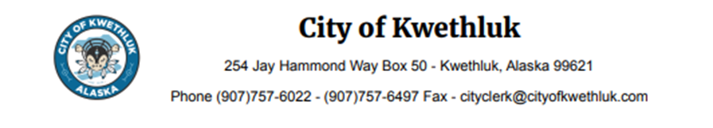
Employment Notice
Job Title: Substitute Utility Clerk
Department: Kwethluk Sanitation
Supervisor: City Manager, Sanitation Coordinator, Kwethluk Sanitation Committee
Positions Supervised: None
Salary: Depending on experience.
Position Description:
The Utility Clerk performs various job duties to include but not limited to; accounting, utility billing, maintaining customer accounts, preparing utility notices to customers, and managing utility service fee collections. Works with the City Clerk to schedule Sanitation Committee meeting dates. Assists the City Treasurer/Bookkeeper in preparation of financial reports, bank deposits, warrant redemption, and any other financial and accounting matters pertinent to the Kwethluk Sanitation Committee as assigned.
Duties and Responsibilities:
- Responsible for Utility billing, prepares shut off notices, manages customer utility accounts, and manages Utility collections.
- Notifies Sanitation Committee members on scheduled dates of meeting date.
- Post adjusting journal entries to utility accounts as needed, receives and deposits Utility revenues.
- Maintain subscription applications, issue yearly services subscription notification through mass mailing and researches options to secure competitive prices for purchases.
- Perform routine tasks as required such as computer data entry, word processing, and producing excel spreadsheets as required.
- Respond to public inquiries and requests for information concerning utility accounts.
Education and Experience:
- High School Diploma or GED.
- Two-year degree in Accounting or related field but not mandatory.
- Basic knowledge in budgeting, accounting, and reporting system on QuickBooks pro.
- Ability to follow written and oral directions, work independently, work with customers and public courteously and professionally.
- Excellent written and oral communication skills, and experience in customer service relations.
- Background use of standard office machines and equipment; knowledge of Microsoft, Excel, Access, and PowerPoint.
Application period: Open until filled.

